**如何写邮件邀请朋友参加生日派对**

**写作任务 (Section B 3c)**

假如你是王磊，下周日是你的14岁生日，你准备举办一个派对。你想邀请好友Eric来参加，请给他写一封邮件邀请他前来共庆生日。

**●【审清题目】**

**内容：**邀请好友参加生日派对

**文体：**应用文（邀请函）

**时态：**一般现在时和一般将来时

**人称：**第一人称和第二人称

**【头脑风暴】**

|  |  |
| --- | --- |
| To whom | Eric |
| For what | Birthday party |
| When (date and time) | At 6:00 p.m. next Sunday |
| Where (place) | ... |
| Other information | Things to do, things to bring or clothes to wear |
| Ask for reply | ... |

**●【提供素材】**

**◆句型** 根据汉语提示，写出对应的英文表达。

**发出邀请：**

(1)______________________________(我想邀请你参加我的生日派对).

Please join me for my birthday party next Monday.

Please join us for drinks and delicious food on September, 12th.

I'm happy to invite you to join me for my birthday party at my house.

(2)______________________________(你能来参加我的生日派对吗)?

Would you like to come to my birthday party?

I want you to be at my party because you are very special to me.

I'm eager (渴望的) to see you at my party.

**生日派对相关事宜（活动、准备的物品、穿着等）：**

Please bring ...

(3)______________________________(你不需要带任何东西).

We will / are going to sing and dance at the party.

We can eat, drink and play games at the party.

You don't need to dress up for the party.

**提醒回复邀请：**

(4)______________________________(请在下周一之前回复我).

You can send me an e-mail by 5:00 p.m. to let me know if you can come.

Please tell me as soon as possible if you can come to the party.

I hope to hear from you as soon as possible.

Please say “yes”.

**表达诚意：**

Hope you can come.

I do hope you can make it.

(5)______________________________(我期待见到你).

We will be waiting for you.

**Key:**

1. I would like to invite you to (come to) my birthday party

2. Can you come to my birthday party

3. You don't need to bring anything

4. Please reply to me by next Monday

5. I'm looking forward to meeting / seeing you

**●【谋篇布局】** 将括号内的汉语翻译成英语，补全短文。

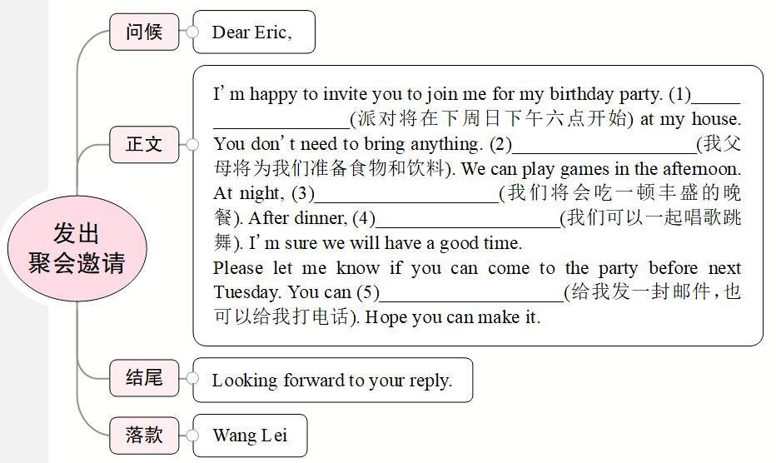

**Key:** 1. The party will begin at six next Sunday afternoon  2. My parents will prepare food and drinks for us

3. we will have a big dinner  4. we can sing and dance together  5. send me an e-mail or call me

**●【小试身手】**

同学们，请你参考**【头脑风暴】**和**【提供素材】**中的内容，写一封邀请函，邀请你的朋友参加你的生日派对吧。

____________________________________________________________________________________________________________________________________________________________________________________________________________________________________________________________________________________